**OUTTER JOIN**

**Outter join:**

1. It returns **both matching and non-matching records**
2. Outer join = inner join + non-matching records
3. Non-matching records means data present in one table, but absent in another table. It will be read and write to use common columns.

**For ex,** 40 is there in deptno of dept table, but not there in deptno of emp table.

***Using right join***

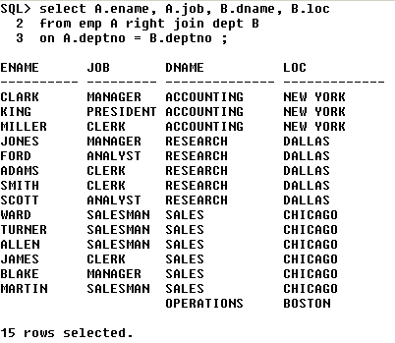

**Types of outter join:**

1. Left outter join
2. Right outter join
3. Full outter join

**Left outter join:**

1. It is used to **display the matched records from both the tables as well as the unmatched records from the left table.**

**EX:**

Table 1={1,2,3,4}

Table 2={3,4,5,6}

**Ansi syntax:**

Select <column_list>

From t1 left outter join t2

On t1.common_column=t2.common_column;

**Oracle syntax:**

Select <column_list>

From t1,t2

Where t1.common_column=t2.common_column(+);

**Right outter join:**

1. It is used to **display the matched records from both the tables as well as the unmatched records from the right table.**

**EX:**

Table 1={1,2,3,4}

Table 2={3,4,5,6}

**Ansi syntax:**

Select <column_list>

From t1 right outter join t2

On t1.common_column=t2.common_column;

**Oracle syntax:**

Select <column_list>

From t1,t2

Where t1.common_column(+)=t2.common_column;

**Full outter join:**

1. It is used to **display both matched records from both the tables.**

**EX:**

Table 1={1,2,3,4}

Table 2={3,4,5,6}

**Ansi syntax:**

Select <column_list>

From t1 full outter join t2

On t1.common_column=t2.common_column;

**Oracle syntax:**

Select <column_list> From t1,t2

Where t1.common_column=t2.common_column(+);

**Union**

Select <column_list>

From t1,t2

Where t1.common_column(+)=t2.common_column;